THE ALDEN SHERMAN CLASSIC
Weston, Connecticut • September 23, 2012

NEWS RELEASE
First Annual Alden Sherman Classic Car Show
To Benefit Weston Senior Center

WESTON, CT, July 26, 2012 – Named after longtime Weston resident and legendary car enthusiast Alden Sherman, the first annual Alden Sherman Classic car show will be held on Sunday, September 23, 10 AM – 3 PM, at Weston High School on School Road. Proceeds from the vintage car and motorcycle show will benefit the Weston Senior Activities Center, which serves and supports the active senior community in Weston and surrounding towns.
The event will showcase premier cars and motorcycles from the collections of classic car enthusiasts from all over the region. Anyone attending the show will have an opportunity to vote for his or her favorite cars and motorcycles in the exhibition. Based on these votes, “People’s Choice” awards will recognize cars in the different decades represented at the show, from pre-war to present day, as well as a special category for motorcycles.
“This will be a wonderful opportunity for classic car and motorcycle collectors to share their passion with other enthusiasts and the greater community for a worthwhile cause,” said Wendy Petty, Director of the Weston Senior Activities Center. “On behalf of the Senior Center, I’d like to thank Alden Sherman for graciously serving as our ambassador to the car enthusiast community and lending his name to our fundraiser. We also have an outstanding group of volunteers from all over Fairfield County who are dedicated to making the show a fun and entertaining event for all.”
“The seniors living in Weston account for nearly 20 percent of the town’s population, and the Center has become an important destination for many,” Petty added. “The funds that we raise from the car show will allow us to expand the number of seniors we serve, as well as help cover the costs of many of our programs, including exercise classes, health and wellness education, social outings and guest speakers.”
Located at Hurlbutt Elementary School on School Road in Weston, the Weston Senior Activities Center provides a variety of social, fitness and educational programs for seniors living in Weston and surrounding towns.
The Alden Sherman Classic is free and open to the public, with an opportunity to make a tax-deductible donation at the entrance to the show. For more information about the show, including tax-deductible sponsorship opportunities and car and motorcycle applications, please visit www.aldenshermanclassic.com or call Wendy Petty at (203) 222-2608.
# # #
Media Contact:
Karen DeMartine
DeMartine Group
203-221-2790
kdemartine@demartinegroup.com

Photo: www.aldenshermanclassic.com/Photos.html

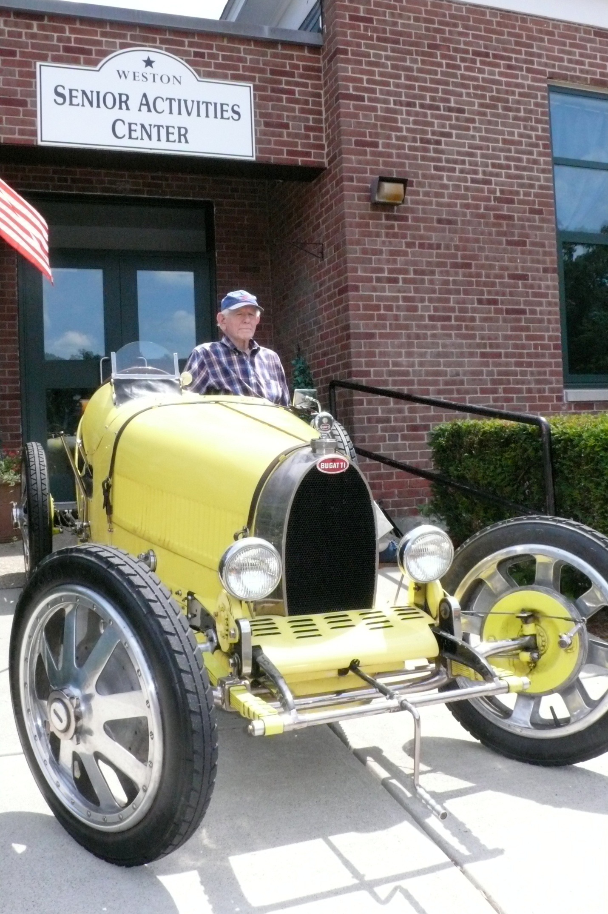

Caption: Well-known classic car enthusiast and local resident Alden Sherman poses in a 1926 Type 37 Grand Prix Bugatti in front of the Weston Senior Activities Center at Hurlbutt Elementary School in Weston, CT. Among the many beautifully restored vintage automobiles and motorcycles to be featured at The Alden Sherman Classic on September 23, this model is one of 291 that were built between 1925 and 1929. Photo by Bob Mitchell.

